EXPERIMENT 8B:

import numpy as np

import matplotlib.pyplot as plt

from skimage import data, color, io, img_as_ubyte

from skimage.filters import sobel

from skimage.segmentation import watershed, mark_boundaries

from skimage.measure import label

from skimage.color import label2rgb

from skimage.morphology import dilation, erosion, square

from skimage.feature import peak_local_max

from scipy import ndimage as ndi

# Load a sample image from skimage

image = data.coins() # Replace with your own image if needed

# Convert the image to grayscale

gray_image = color.rgb2gray(image) if len(image.shape) == 3 else image

# Compute the gradient magnitude using the Sobel filter

elevation_map = sobel(gray_image)

# Markers for the background and the objects

markers = np.zeros_like(gray_image)

markers[gray_image < 30] = 1 # Background

markers[gray_image > 150] = 2 # Objects

# Perform the Watershed algorithm

segmentation = watershed(elevation_map, markers)

# Label the segmented objects

labeled_segments = label(segmentation)

# Visualize the results

fig, axes = plt.subplots(1, 3, figsize=(15, 5))

ax = axes.ravel()

ax[0].imshow(gray_image, cmap='gray')

ax[0].set_title('Original Image')

ax[1].imshow(elevation_map, cmap='gray')

ax[1].set_title('Elevation Map')

ax[2].imshow(mark_boundaries(gray_image, labeled_segments))

ax[2].set_title('Segmentation')

for a in ax:

a.axis('off')

plt.tight_layout()

plt.show()

# Optional: Further evaluation using metrics (if ground truth is available)

# For demonstration, we assume a ground truth mask is available

# ground_truth = ...

# Compute evaluation metrics

# jaccard_index = jaccard_score(ground_truth.flatten(), labeled_segments.flatten(), average='macro')

# dice_coefficient = f1_score(ground_truth.flatten(), labeled_segments.flatten(), average='macro')

# Print evaluation metrics

# print(f'Jaccard Index: {jaccard_index}')

# print(f'Dice Coefficient: {dice_coefficient}')

OUTPUT:

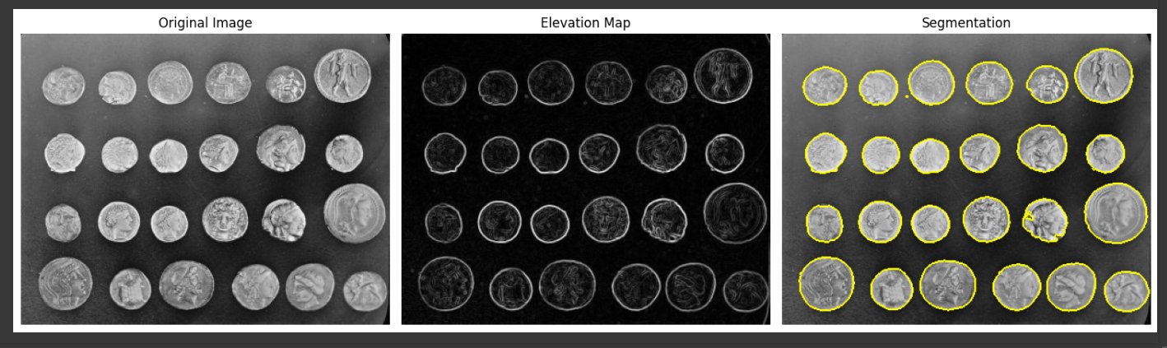

EXPERIMENT 9A:

import tensorflow as tf

from tensorflow.keras import datasets, layers, models

import matplotlib.pyplot as plt

# Load and preprocess the MNIST dataset

(X_train, y_train), (X_test, y_test) = datasets.mnist.load_data()

X_train, X_test = X_train / 255.0, X_test / 255.0 # Normalize the images to [0, 1]

# Flatten the images for the fully connected layers

X_train = X_train.reshape(-1, 28 * 28)

X_test = X_test.reshape(-1, 28 * 28)

# Build the neural network model

model = models.Sequential([

layers.Dense(128, activation='tanh', input_shape=(28 * 28,)),

layers.Dense(64, activation='tanh'),

layers.Dense(10, activation='softmax')

])

# Compile the model

model.compile(optimizer='adam',

loss='sparse_categorical_crossentropy',

metrics=['accuracy'])

# Train the model

history = model.fit(X_train, y_train, epochs=10,

validation_data=(X_test, y_test))

# Evaluate the model

test_loss, test_acc = model.evaluate(X_test, y_test, verbose=2)

print(f'\nTest accuracy: {test_acc}')

# Plot training & validation accuracy values

plt.figure(figsize=(12, 4))

plt.subplot(1, 2, 1)

plt.plot(history.history['accuracy'])

plt.plot(history.history['val_accuracy'])

plt.title('Model accuracy')

plt.ylabel('Accuracy')

plt.xlabel('Epoch')

plt.legend(['Train', 'Test'], loc='upper left')

# Plot training & validation loss values

plt.subplot(1, 2, 2)

plt.plot(history.history['loss'])

plt.plot(history.history['val_loss'])

plt.title('Model loss')

plt.ylabel('Loss')

plt.xlabel('Epoch')

plt.legend(['Train', 'Test'], loc='upper left')

plt.tight_layout()

plt.show()

# Visualize some predictions

predictions = model.predict(X_test)

plt.figure(figsize=(10, 10))

for i in range(25):

plt.subplot(5, 5, i + 1)

plt.xticks([])

plt.yticks([])

plt.grid(False)

plt.imshow(X_test[i].reshape(28, 28), cmap=plt.cm.binary)

plt.xlabel(f"True: {y_test[i]}\nPred: {predictions[i].argmax()}")

plt.show()

OUTPUT:

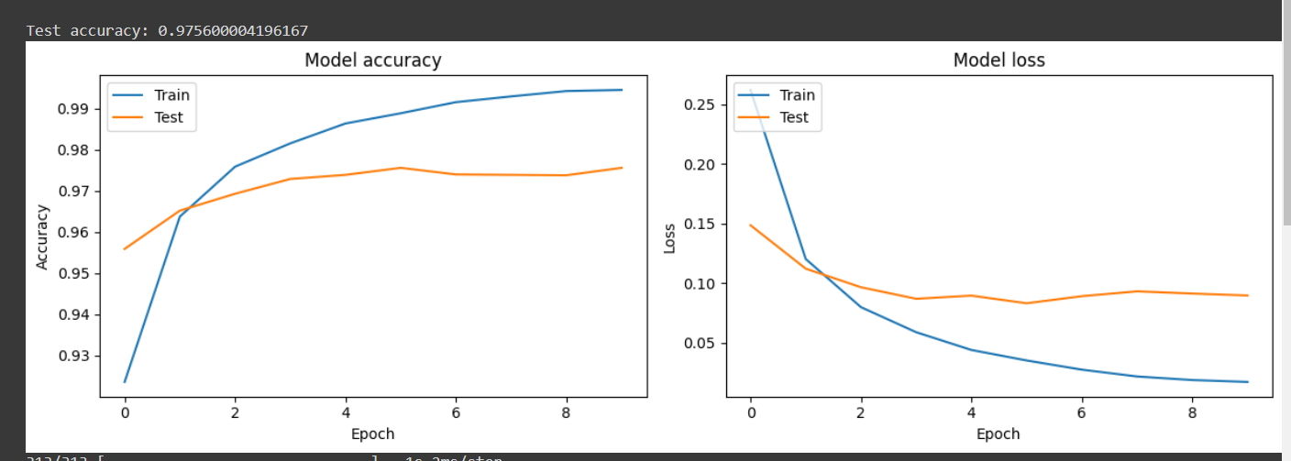

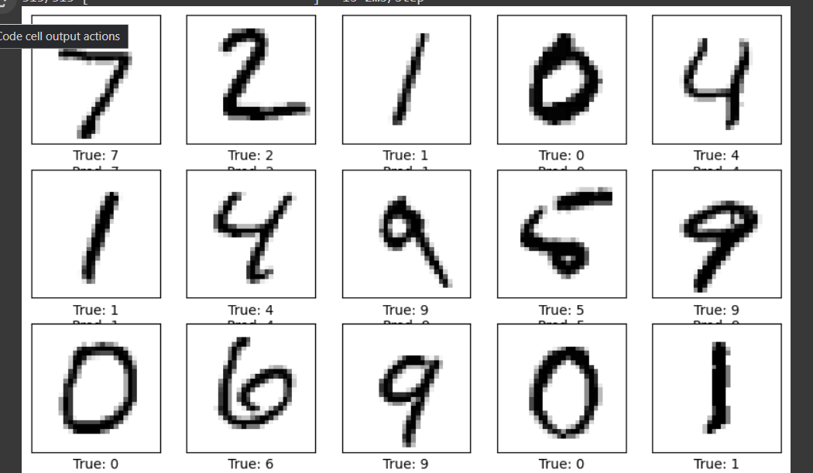

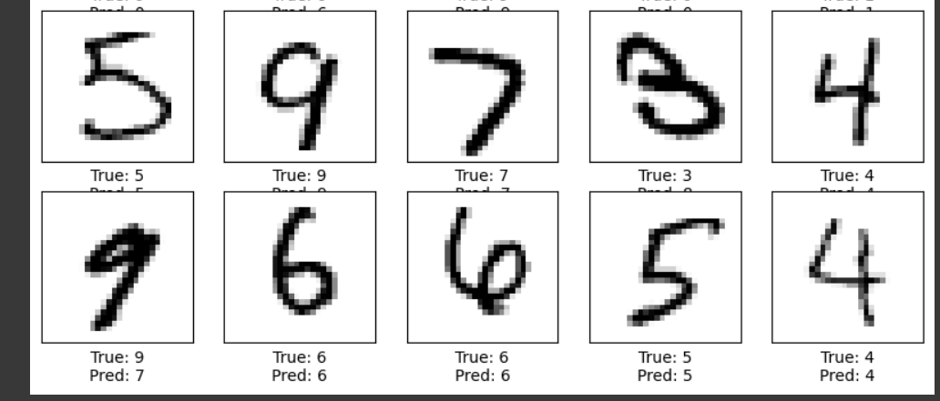

EXPERIMENT 9B::

import tensorflow as tf

from tensorflow.keras import datasets, layers, models

import matplotlib.pyplot as plt

# Load and preprocess the MNIST dataset

(X_train, y_train), (X_test, y_test) = datasets.mnist.load_data()

X_train, X_test = X_train / 255.0, X_test / 255.0 # Normalize the images to [0, 1]

# Flatten the images for the fully connected layers

X_train = X_train.reshape(-1, 28 * 28)

X_test = X_test.reshape(-1, 28 * 28)

# Build the neural network model

model = models.Sequential([

layers.Dense(128, activation='sigmoid', input_shape=(28 * 28,)),

layers.Dense(64, activation='sigmoid'),

layers.Dense(10, activation='softmax')

])

# Compile the model

model.compile(optimizer='adam',

loss='sparse_categorical_crossentropy',

metrics=['accuracy'])

# Train the model

history = model.fit(X_train, y_train, epochs=10,

validation_data=(X_test, y_test))

# Evaluate the model

test_loss, test_acc = model.evaluate(X_test, y_test, verbose=2)

print(f'\nTest accuracy: {test_acc}')

# Plot training & validation accuracy values

plt.figure(figsize=(12, 4))

plt.subplot(1, 2, 1)

plt.plot(history.history['accuracy'])

plt.plot(history.history['val_accuracy'])

plt.title('Model accuracy')

plt.ylabel('Accuracy')

plt.xlabel('Epoch')

plt.legend(['Train', 'Test'], loc='upper left')

# Plot training & validation loss values

plt.subplot(1, 2, 2)

plt.plot(history.history['loss'])

plt.plot(history.history['val_loss'])

plt.title('Model loss')

plt.ylabel('Loss')

plt.xlabel('Epoch')

plt.legend(['Train', 'Test'], loc='upper left')

plt.tight_layout()

plt.show()

# Visualize some predictions

predictions = model.predict(X_test)

plt.figure(figsize=(10, 10))

for i in range(25):

plt.subplot(5, 5, i + 1)

plt.xticks([])

plt.yticks([])

plt.grid(False)

plt.imshow(X_test[i].reshape(28, 28), cmap=plt.cm.binary)

plt.xlabel(f"True: {y_test[i]}\nPred: {predictions[i].argmax()}")

plt.show()

OUTPUT:

